**Power BI Assignment-5**

1. Explain DAX.

Ans:

1. DAX (Data Analysis Expressions) is a formula expression language and can be used in different BI and visualization tools.
2. DAX is also known as function language, where the full code is kept inside a function.
3. DAX programming formula contains two data types: Numeric and Other.
4. Numeric includes - integers, currency, decimals, etc.

Other includes - strings, binary objects, etc.

1. DAX function can also include other functions, conditional statements & value references. Such as:
   * + - Aggregate – min(), max(), sum(), avg(), sumx()
       - Text – replace(), search(), upper(), fixed(), concatenate()
       - Date – date(), hour(), weekday(), now(), eomonth()
       - Logical – AND, OR, NOT, IF, IFERROR
       - Counting – distinct count(), count(), countA(), countrows(), countblank()
       - Information – isblank(), isnumber(), istext(), isnontext(), iserror()
2. Explain datasets, reports, and dashboards and how they relate to each other.

Ans:

1. Datasets, reports, and dashboards are core components that work together to enable data analysis and visualization. Here's how they relate to each other:
2. **Datasets**: In Power BI, a dataset represents a collection of tables and data that are imported or connected from various sources. Datasets can be created within Power BI or connected to external data sources such as databases, Excel files, or online services.
3. **Reports**: Reports in Power BI are visual representations of data derived from datasets. They are interactive and dynamic, allowing users to explore and analyze the data. Reports in Power BI consist of visualizations like charts, tables, matrices, and other graphical elements that help users gain insights from the data.
4. **Dashboards**: Dashboards in Power BI are personalized collections of visualizations, reports, and key metrics that provide a high-level overview of business data and performance. Users can pin specific visualizations, tiles, or entire reports to a dashboard to create a customized view of the data.
5. In the Power BI ecosystem, datasets are the foundation that holds the data, reports transform and visualize that data in a meaningful way, and dashboards provide a consolidated and interactive view of the most relevant information from the reports.

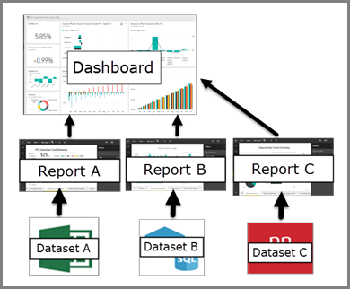

1. How reports can be created in Power BI, explain two ways with Navigation of each.

Ans:

1. A Power-BI report is the ‘Power-BI way’ of showing findings and insights from a dataset. In Power BI, reports can be created using two primary methods: Power BI Desktop and Power BI Service
2. **Power BI Desktop** – Can create a Power-BI report on Power-BI Desktop Tool.

•Install Power-BI Desktop for Power-BI report server.

•After downloading the installer, run the Power-BI Desktop setup wizard.

•At the end of the installation, check starts Power-BI Desktop now.

•Select a data source. From the welcome screen-> select get data -> select data source -> import the data -> load the Power-BI field.

•Design report. We can create visuals that illustrate our data.

•Save the report to the report server or can save it on a local computer.

•Publish to Power-BI report online in the Power-BI service.

1. **Power BI Service** – We can directly create a Power-BI report on Power-BI Web Tool. Power-BI web tool enables us to directly import the data source onto Power-BI on the web and automatically generate the report.

•Selecting our data source. Go to the left navigation pane and click on the ‘create’ button. Only paste data directly or choose data from an Excel file.

•Selecting the data types for attributes. Power-BI automatically detects the data types, but we have the option to manually set them using the data type button to the left of the column name.

•Summarizing our data source using create flow. It enables us to create a new data set and automatically generates a summarized version of the data using create flow.

•This helps us to transform raw data into valuable insights within a matter of clicks.

•Editing fields using the summarize pane. Power-BI report design method, we can make reports as per our needs by editing them easily.

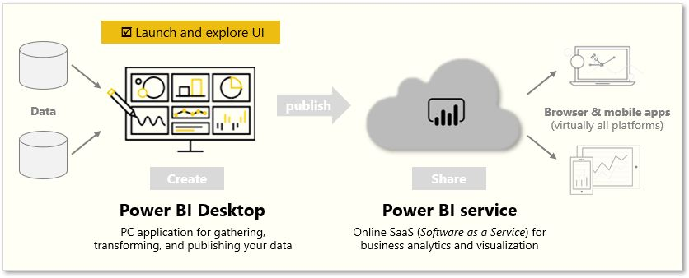

1. How to connect to data in Power BI? How to use the content pack to connect to Google Analytics? Mention the steps.

Ans:

i. To connect to data in Power BI, you can follow these steps:

* Launch Power BI Desktop or Power BI Service.
* Navigate to the "Home" tab or "Get Data" button.
* Choose your data source from the available options (e.g., files, databases, online services, etc.).
* Provide the necessary credentials or connection details.
* Select the specific tables or data you want to import.
* Apply any desired transformations or data shaping.
* Load the data into Power BI for analysis and visualization.

ii. To use the content pack to connect to Google Analytics in Power BI, follow these steps:

* Open Power BI Service and sign in to your account.
* Click on the "Get Data" button in the left navigation pane.
* Select "Services" from the categories on the left.
* Choose "Google Analytics" from the available services.
* Click on "Connect" to initiate the connection process.
* Provide your Google Analytics account credentials.
* Select the specific Google Analytics view/profile you want to connect to.
* Customize the import settings, such as the date range and data granularity.
* Click on "Load" to import the data into Power BI.
* Once the import is complete, you can start analyzing and visualizing the Google Analytics data in Power BI.

1. How to import Local files in Power BI? Mention the Steps.

Ans: To import local files in Power BI, follow these steps:

* Launch Power BI Desktop or Power BI Service.
* Navigate to the "Home" tab or click on the "Get Data" button.
* Choose the "File" option from the available data connection options.
* Select the type of file you want to import, such as Excel, CSV, Text, or JSON.
* Browse and locate the local file on your computer.
* Choose the specific file or sheet (if applicable) you want to import.
* Apply any desired data transformations or cleaning steps.
* Preview the data to ensure it’s imported correctly.
* Click on "Load" to import the data into Power BI.
* Once the import is complete, the data will be available for analysis and visualization in Power BI.

1. In Power BI visualization, what are Reading View and Editing View?

Ans:

1. In Power BI visualization, the Reading View and Editing View are two different modes for interacting with and modifying a report.
2. **Reading View**: Reading View is the mode that allows users to consume and explore a report without making any changes. It is designed for viewing and interacting with the report's visualizations, applying filters, drilling down into details, and analyzing the data. Users can interact with the report's elements, but they cannot modify the report's structure or design in this mode.
3. **Editing View**: Editing View is the mode that enables users to make changes to the report's structure, design, and data connections. In Editing View, users can add, remove, or rearrange visualizations, modify their properties, create new pages, set up filters and interactions, define calculations and measures, and connect to additional data sources. It provides a comprehensive set of editing capabilities to customize and enhance the report's appearance and functionality.
4. Switching between Reading View and Editing View allows users to switch between consuming and modifying the report, depending on their needs and permissions.